Parrotfeather
Myriophyllum aquaticum
Parrotfeather was listed as a Class B weed in the State of Washington in 1993. It is an ornamental aquatic plant that has escaped cultivation. It is found in freshwater ponds, streams, lakes and canals. Infestations can alter aquatic ecosystems. It forms dense mats that shade out other native aquatic plants as well as inhibit water flow and recreational activities. The only confirmed location in Asotin County is in a small pond west of Evans Road.
The flowers are inconspicuous and white in leaf axils of emergent stems. Since only female plants are present in North America, parrotfeather reproduces by stem and rhizome fragments. The leaves are feather-like and arranged in whorls of 4 to 6 leaves. Emergent leaves are bright green and look similar to little fir trees. Submersed leaves are darker. Emergent stems can grow up to a foot out of the water. Submersed stems may grow up to 16 feet long.
Parrotfeather can be difficult to control. Since it spreads by stem and rhizome fragments, mechanical methods such as cutting, harvesting and underwater tilling is not advisable. These methods can increase infestations by dispersing plant fragments that may root in uninvaded areas. It is not palatable to grass carp.
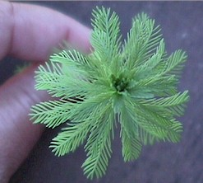
Parrotfeather looks similar to Eurasian watermilfoil (Myriophyllum spicatum), which is also a Class B noxious weed in Washington.
