Cow Parsnip
Heracleum lanatum

This native perennial, belonging to the carrot family, can grow up to 15 feet in height although it usually only grows six feet tall in Asotin County. Easily recognized by its large hairy leaves (sometimes 12” wide) and its conspicuous white, umbrella shaped flower heads, it has a hollow stem and a stout tap root. This attractive, showy plant grows in the higher elevations in Asotin County in damper soils with an over-story of either deciduous or coniferous trees.

Cow parsnip causes photophytodermatitis. The furanocoumarin toxins cause skin rashes and blisters to form after contact with the plant and then exposure to sunlight. The degree of skin damage depends upon individual sensitivity and the maturity of the plant: the younger the plant, the higher the concentrations of toxins. Blisters 2”-3” in diameter are not an uncommon consequence of exposure. These blister areas will form scars that last up to one year or longer.

The introduced ornamental, giant hogweed, is a Class A Noxious Weed in the State of Washington. It is in the same genus as cow parsnip. It has similar toxins but the resulting scars may be life-long. Although primarily a “west side” plant, its eastern boundaries extend to Klickitat County. Since it is considered an ornamental, it may be found in gardens in our area. Use care when dealing with this plant.

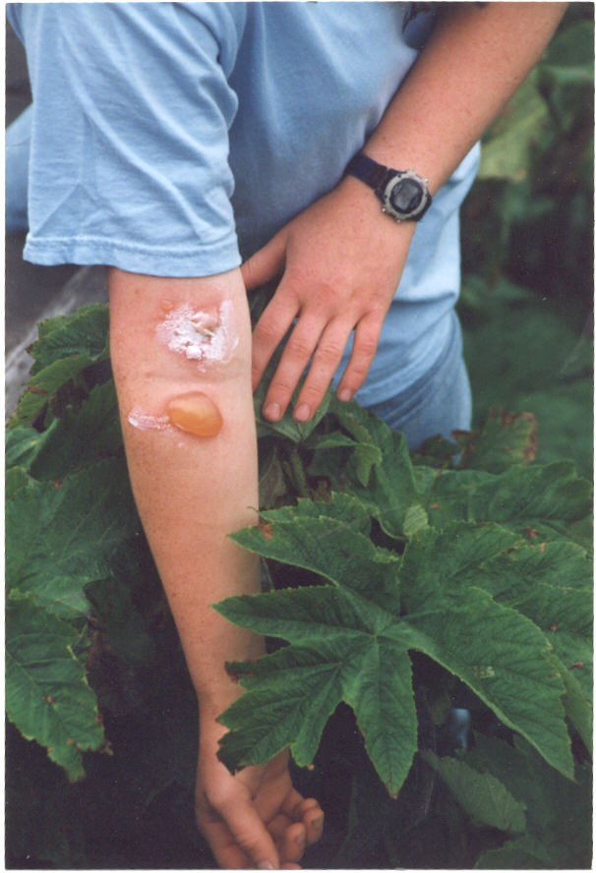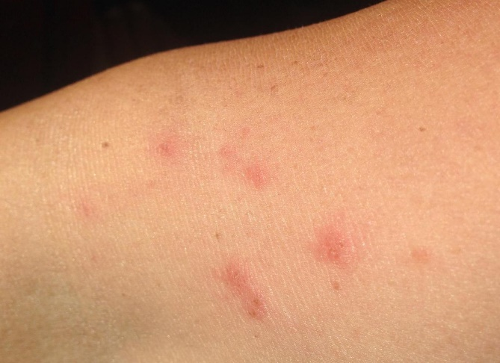

Some people become less sensitive the more they are exposed to this weed. The picture on the left shows initial exposure. The picture on the right shows tiny blisters after years of exposure.

